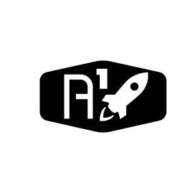DESIGN DOCUMENT

Area : Converse Engine

Category: Feed (Piping)

TEAM: Propulsion

Nyameaama Gambrah

SOLENOID VALVE

Signal-IN

GND

VCC

GND

+5V

D-Pin

GND

DIGITAL PIN-OUT

5V

Relay Module

ECU

Valve